Lab Exercise 18- Scanning IaC Templates for Vulnerabilities
Name- Garvit janu
SAP ID-500119646
Batch-3
Objective
- Learn how to scan Infrastructure as Code (IaC) templates for security vulnerabilities.
- Use open-source IaC security tools to detect misconfigurations.
- Understand common risks such as public access, unencrypted resources, and insecure network rules.

Step 1: Create an Insecure IaC Template
Create a file named main.tf with the following Terraform code:
provider "aws" { region = "us-east-1"
}

resource "aws_s3_bucket" "insecure_bucket" { bucket = "my-insecure-bucket-lab"
acl = "public-read"
}
resource "aws_security_group" "insecure_sg" {
name = "insecure-sg" description = "Allow all inbound traffic"
ingress { from_port = 0 to_port = 65535 protocol = "tcp" cidr_blocks = ["0.0.0.0/0"]
}
}
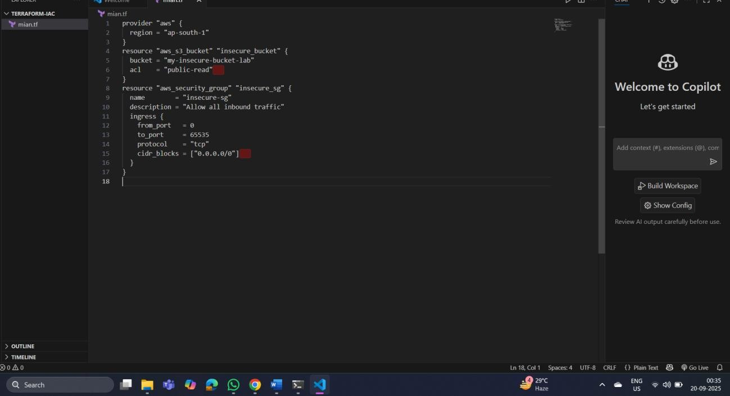

Step 2: Scan the Template with Checkov Run Checkov on the current directory:
checkov -d .
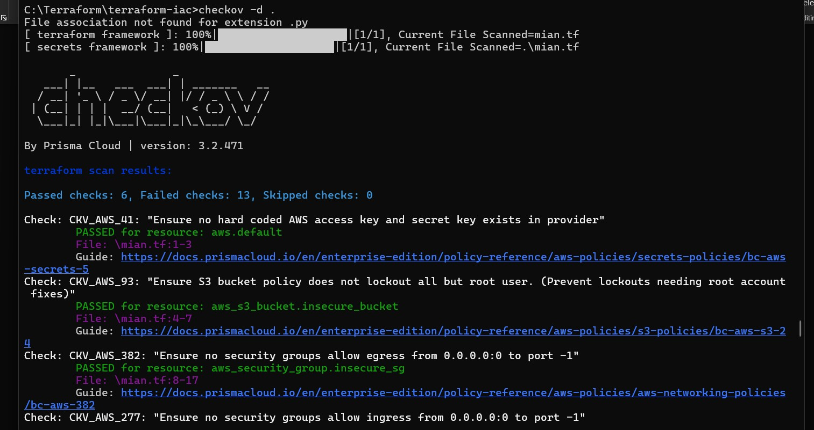
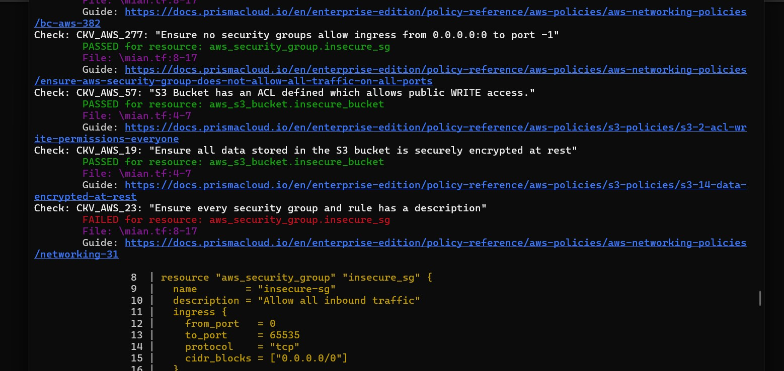
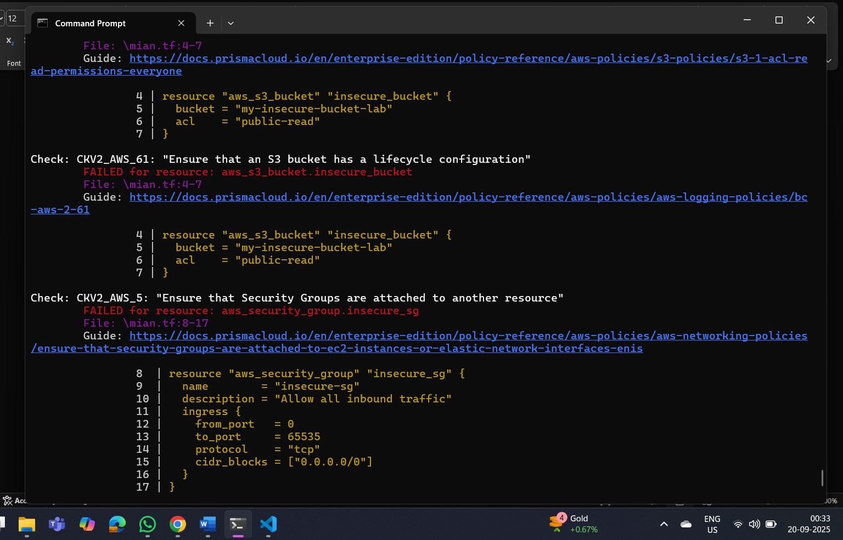
Expected Findings:
- Public S3 bucket access (public-read)
- Security group open to all inbound traffic

Expected Findings:
- Warns about S3 bucket without encryption
- Flags open Security Group rules

Step 4: Review the Report
Example output (Checkov):
Check: CKV_AWS_20: "S3 Bucket allows public read access"
FAILED for resource: aws_s3_bucket.insecure_bucket
Check: CKV_AWS_260: "Security group allows ingress from 0.0.0.0/0"
FAILED for resource: aws_security_group.insecure_sg

Step 5: Apply Fixes (Optional) Modify the IaC template to:
- Set S3 bucket ACL to private
- Enable encryption (AES256)
- Restrict Security Group to specific IP ranges
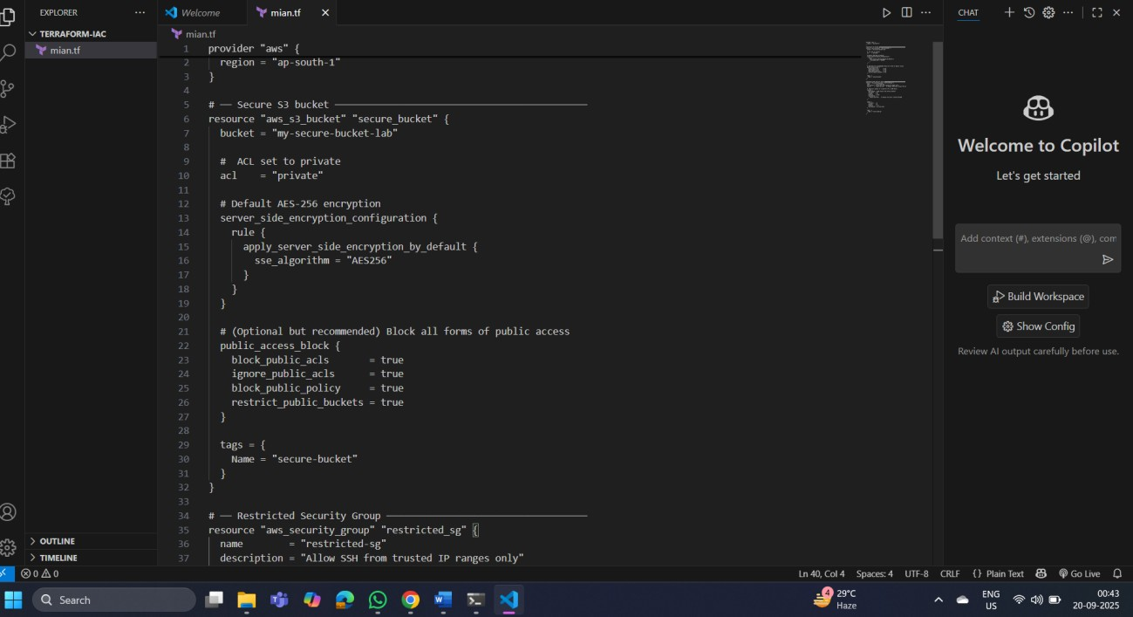
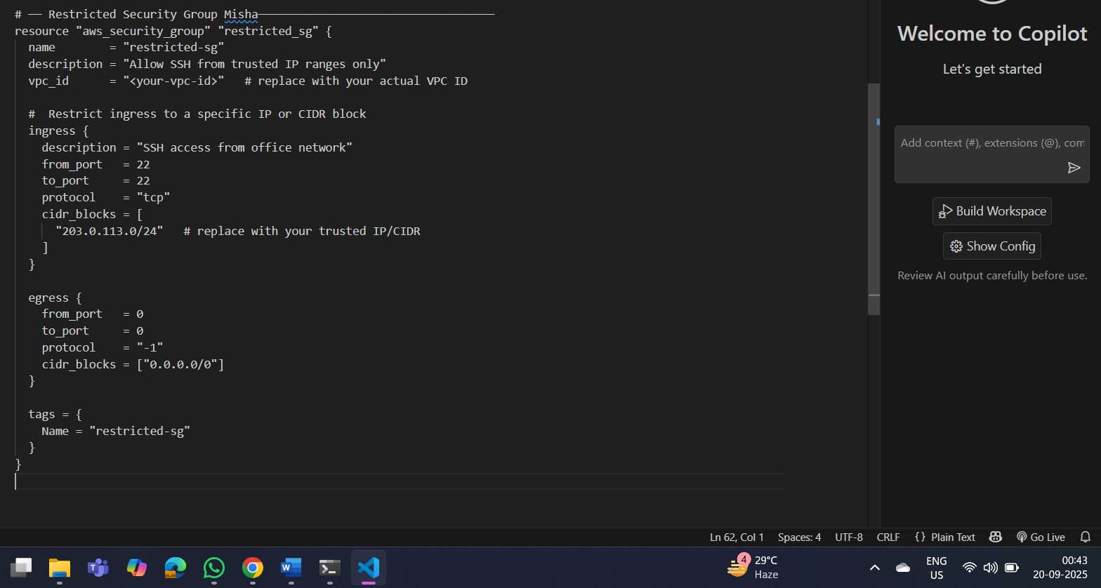

Step 6: Rescan the Template
Run the scan again:
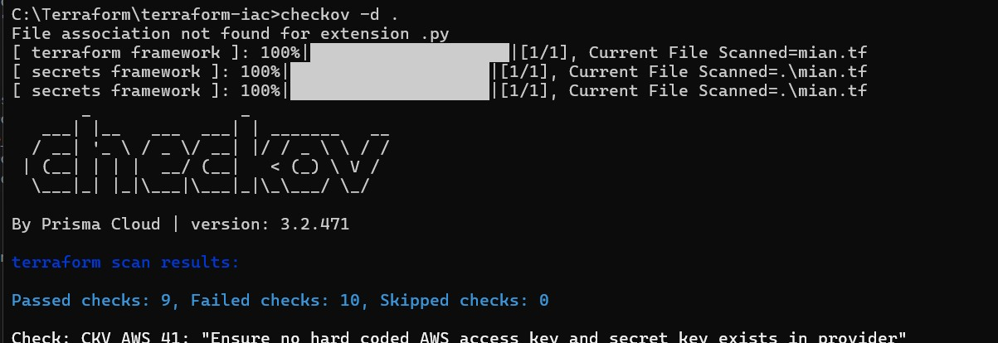
checkov
-
d .

Now the findings should be
resolved or reduced
.

Step 7: Document Findingss Create a simple findings log:
Before the securing, terraform scan results
Passed checks: 6, Failed checks: 13, Skipped checks: 0 After securing- terraform scan results:
Passed checks: 9, Failed checks: 10, Skipped checks:
The number of failed test checks reduced,.

